**Name HASSAN WASEEM**

**Reg No. 16944**

**Semester** **6TH**

**HISTORY OF FILM, TV & ANIMATION**

**Marketing in Bollywood Movies**

Marketing through movies is the easiest and the quickest way to reach those billion people at once. Therefore, many big brands tie-up with movies so they reach their target audience. There are large amount of movies which has done product placement in the movies some of these are as follows

1. **Bournvita in the Koi Mil Gaya franchise.**

Forget Jadoo. Looks like it was Bournvita that'd given Rohit all those magical

Powers.

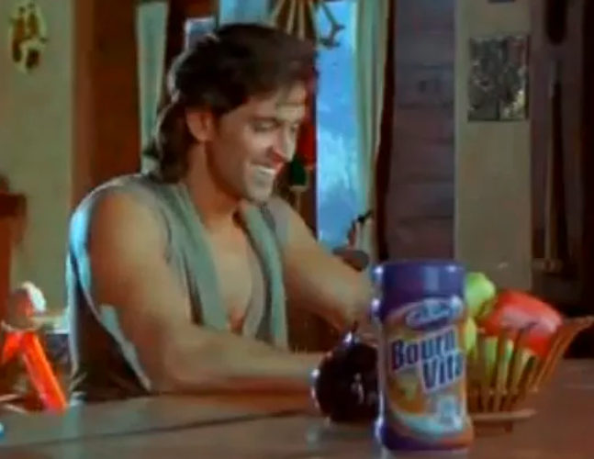

And not just Rohit. Even his son Krrish is addicted to it. The placement of Bournvita is such, that even if you close your eyes, you won't be able to ignore it.

Like seriously, who keeps a jar of Bournvita alongside their research papers? But these are the techniques by which they show every sponsor product in any scenes

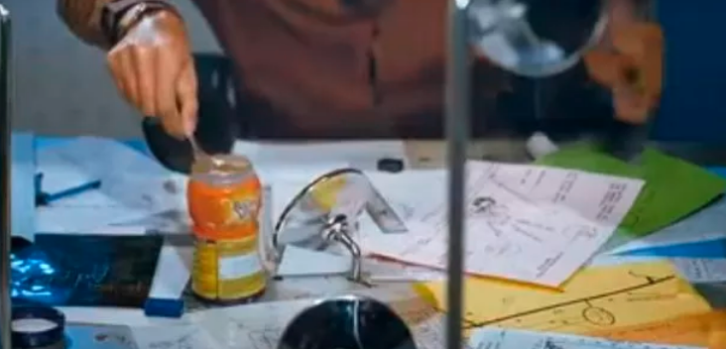

1. **Domino’s Pizza- Phir Hera Pheri**

We all remember the iconic comedy scene of Phir Hera Pheri where Paresh Rawal insisted on the fact that Pizza would be free if it did not get delivered within thirty minutes. This scene was intended to advertise the smooth and fast service of Dominos. Paresh Rawal was even quoted as saying in the movie that the Pizza boy reaches in twenty minutes

